ReactJS Hands On Learning – 02

Folder structure:
Components
-Home.js
-Contact.js
-About.js
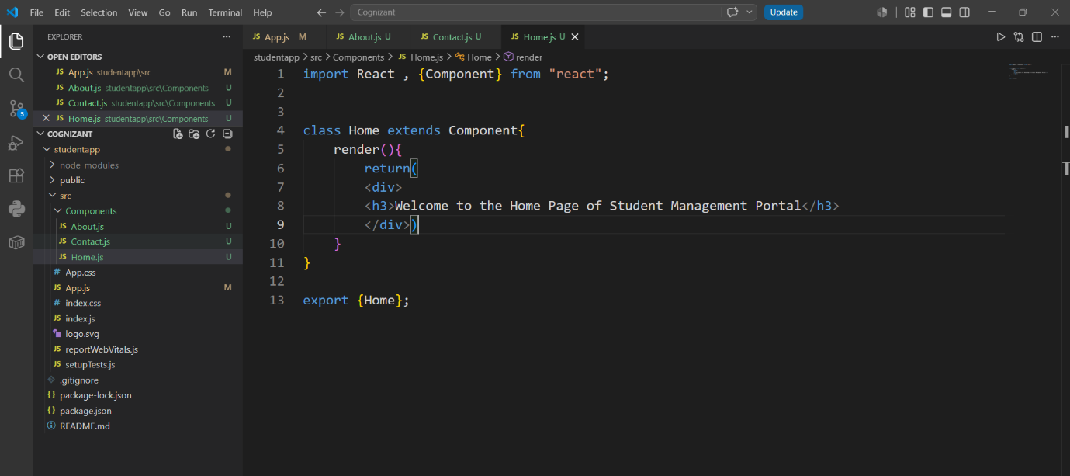

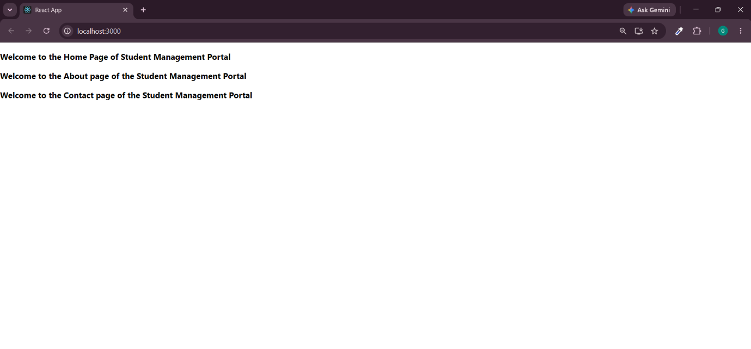
Output:

